Step 1

Create Repo

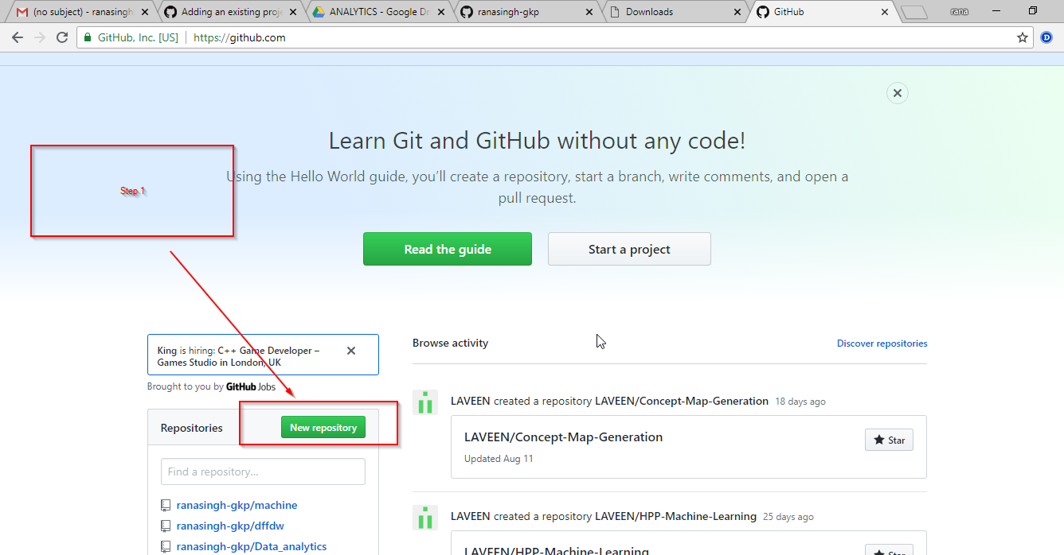

Step 2

Type name of repo

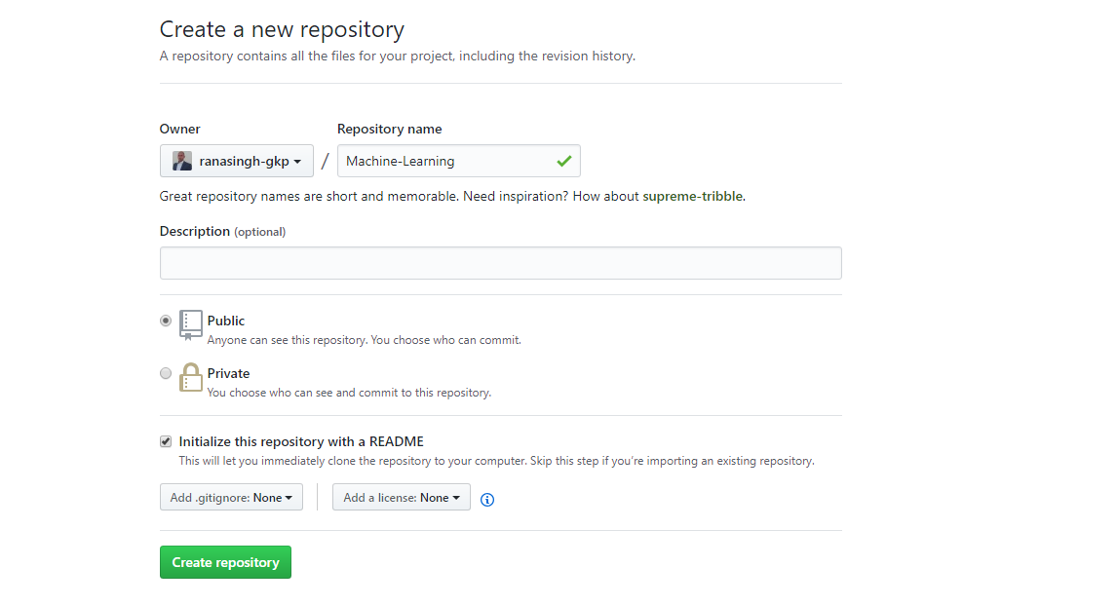

Step 3 & stemp 4

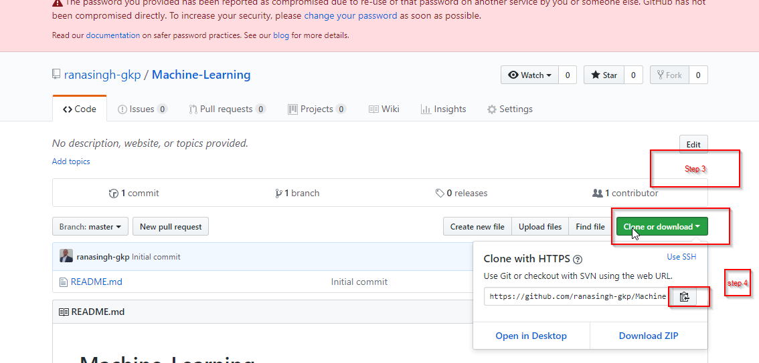

git add *

Type below command in “git bash here” software

git config --global http.proxy <http://172.16.2.30:8080>

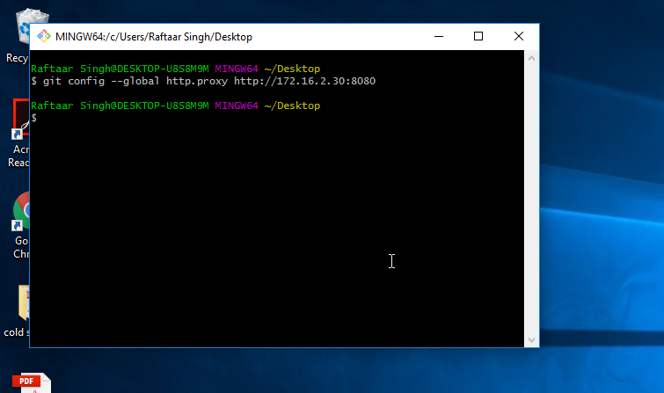

**git clone** [**https://github.com/ranasingh-gkp/machine.git**](https://github.com/ranasingh-gkp/machine.git)

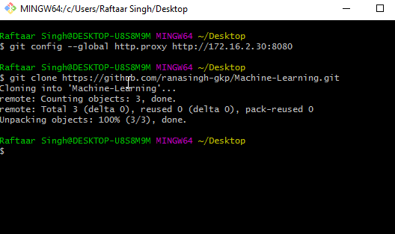

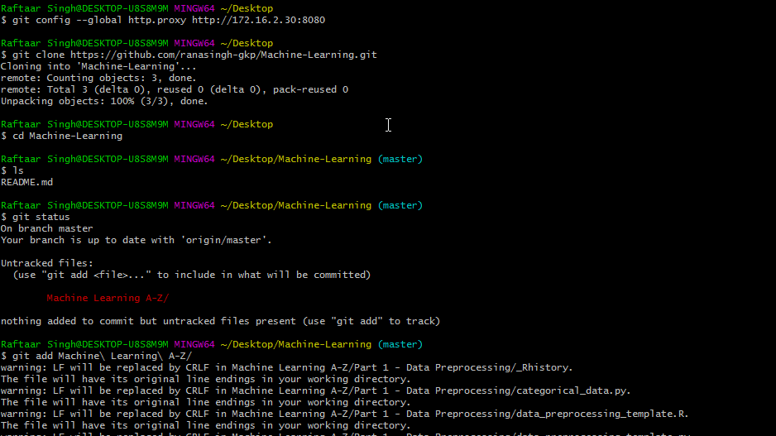

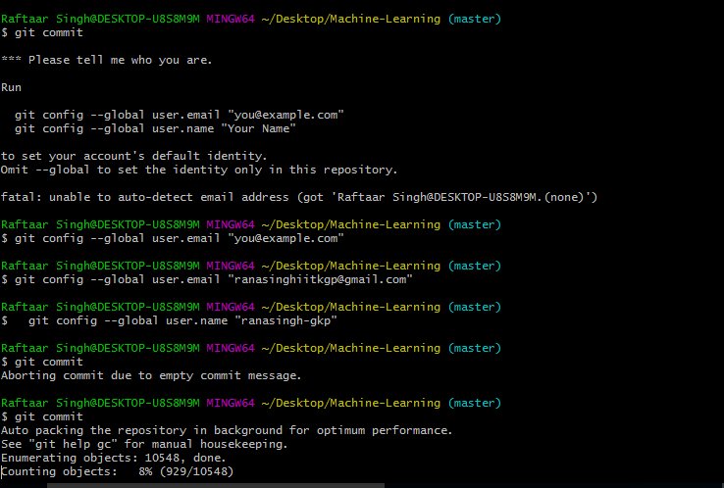

[In commit message , press “escape” then type “:wq” after entering all messages]

(before pressing escape—write anything in commit message)

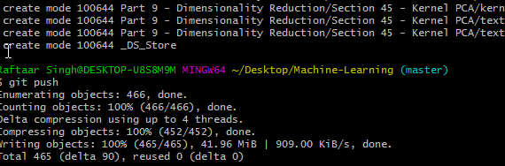

To add readme note

C:\Users\Ami Laddani\Desktop\ra\machine>git add README.md

C:\Users\Ami Laddani\Desktop\ra\machine>git add "Part 5 - Association Rule Learning"

warning: LF will be replaced by CRLF in Part 5 - Association Rule Learning/Section 28 - Apriori/Market_Basket_Optimisati